# All Phases:

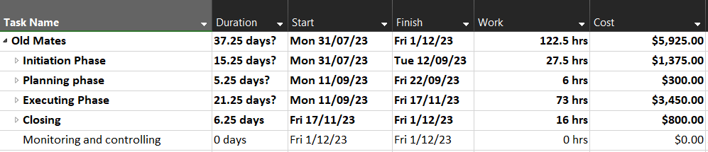

# Task information, resource info

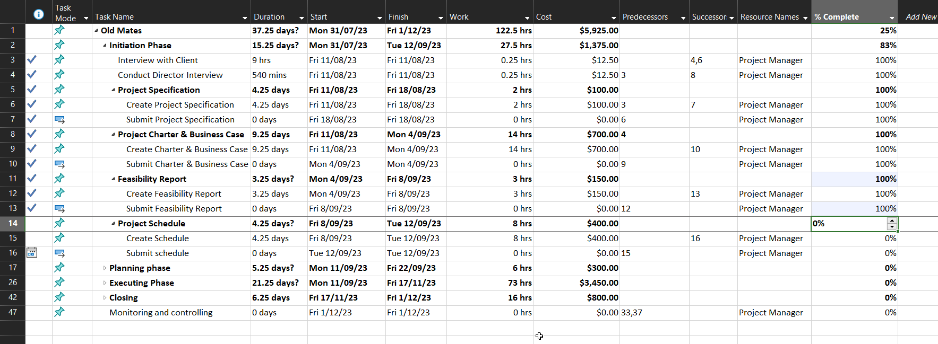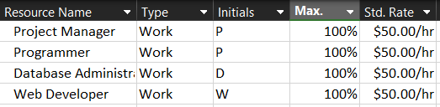

|  |  |
| --- | --- |
|  |  |
|  |  |

|  |  |
| --- | --- |
|  |  |
|  |  |

# Gantt chart

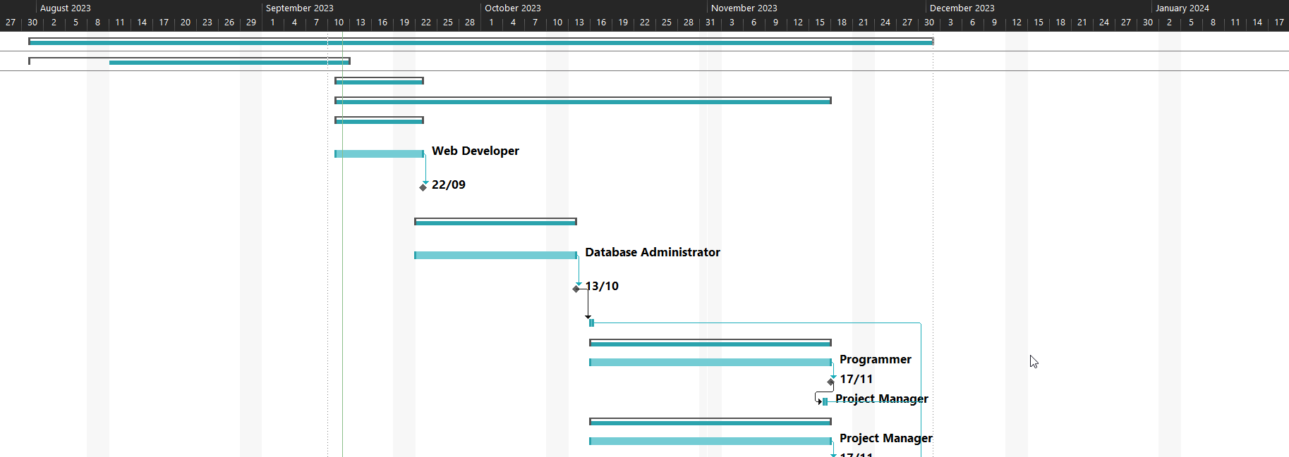

# Resource Usage

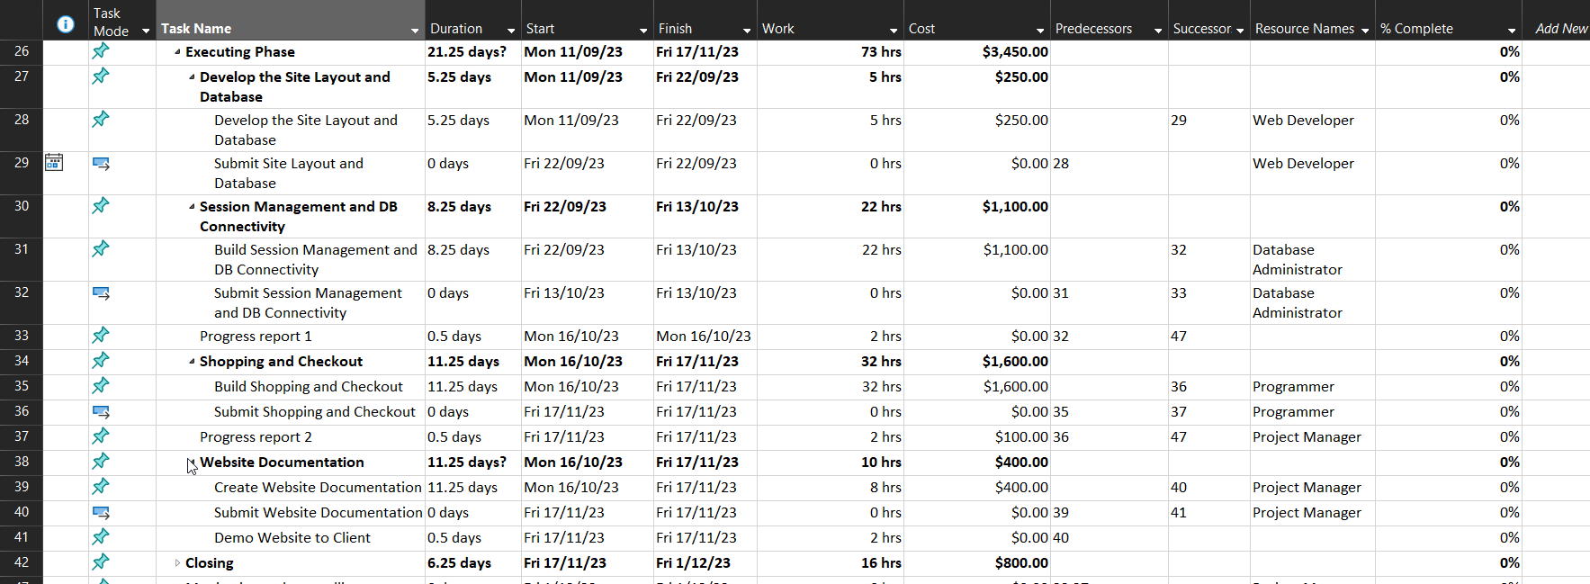

# Cost

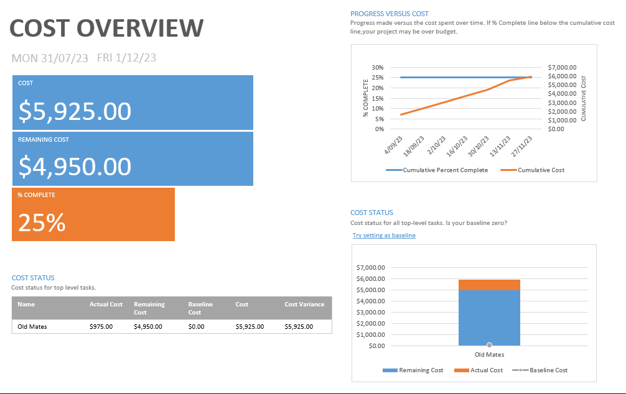

Director Name: _______________ Signature: ___________